**STEP 1 Installing the PHP**

1. Search XAMMP Download

<https://www.apachefriends.org/download.html>

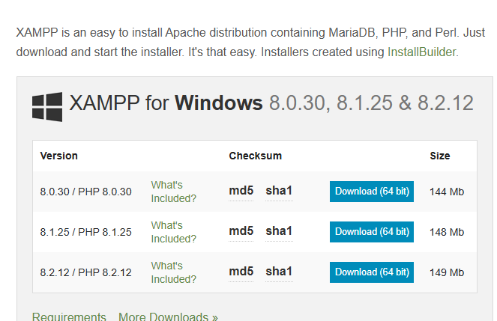

1. Navigating Through the XAMMP

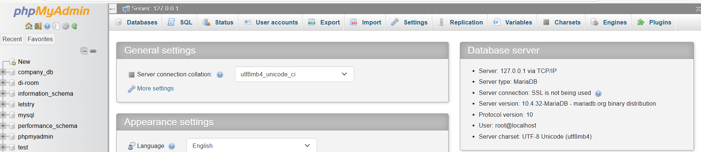

1. Navigating the XAMMP in VS Code

1. **Creating The forms in VS-Code to be able to create the tables**

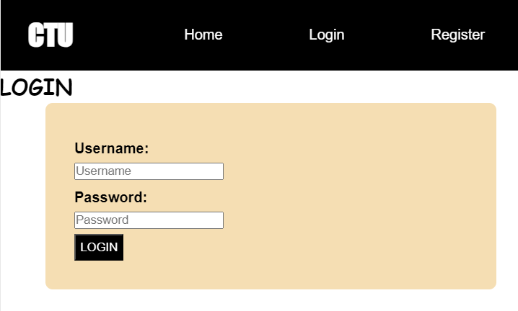

1. **Creating Tables in XAMPP**

**Activities**

* Creating a tables called Registration, Plots, Messages based on The form inputs

1. Adding the PHP and Linking the PHP files with .Html files for forms





1. Hosting the website with Netlify

[Log in | Netlify](https://app.netlify.com/login)

* **After Login Click on Add new Project then Deploy Manually then you will see the window as below**

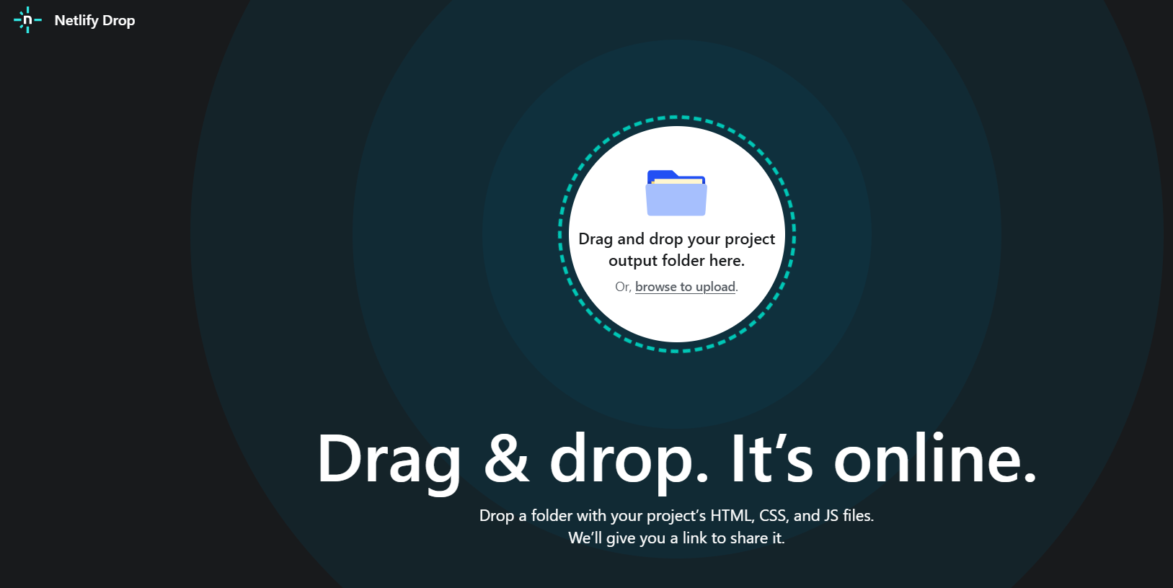

**It being successful you will see the below will all the files making you project at the end.**

* Click on the tabular --- That will be name of your website
* Or click on Project configuration to rename it to your own name e.g Letsee  **name** **below**
* 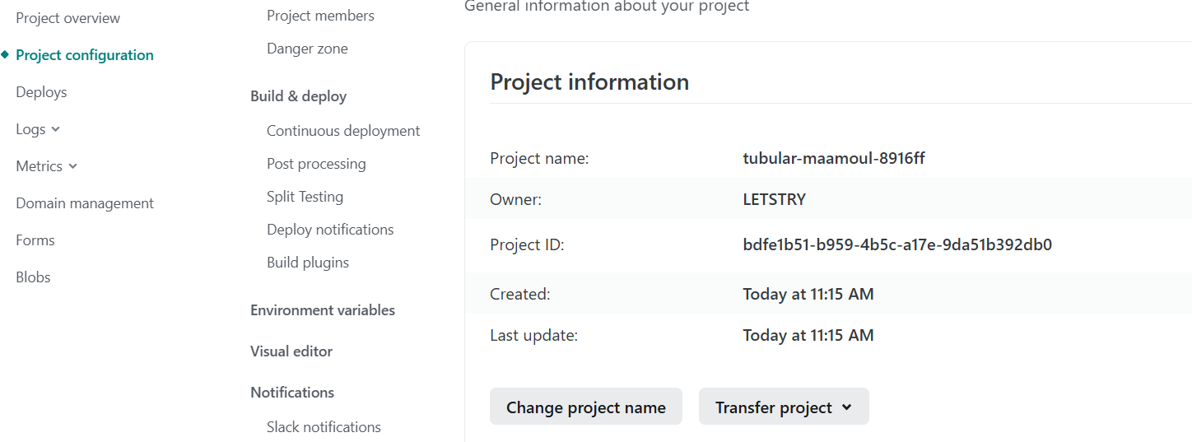
* 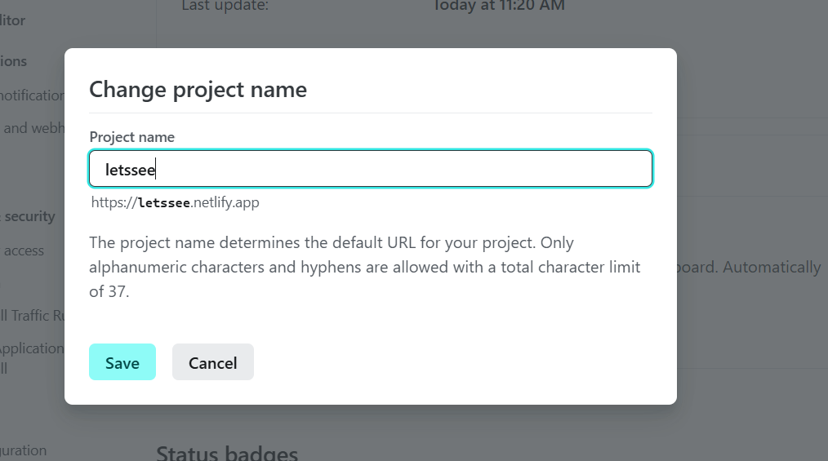

<http://localhost/Ticket%20Hub/Register.html>

[Document](http://localhost/Ticket%20Hub/Login.html)